Joel Edwards
Course: Java Programming 2
Homework 2
September 26, 2011

I created the Rectangle class according to the specification. I created a Main class containing the static main entry point. In here I created the requested data structures, plus two additional in order to track what was happening with the rectangle objects. I confirmed that the Sets did not store any duplicates by piping the results for each through “sort | uniq | wc -l” in the shell.

I created a HashSet with 256 base elements, and TreeSet, and an ArrayList with 1000 elements. I noticed that there were only 100 elements stored in the Sets, while there were always 1000 values in the ArrayList. So I created two HashMaps; one to store the Rectangles, and a second to count the number of rectangles associated with each key.

I realized that the reason I never had more than 100 keys within the Sets and Maps is because of the limited value ranges for the height and width values within the Rectangle class. With 10 possible values for both width and height, there are a total of 100 possibilities. If the range of these values were increased,

I initially only created Rectangles with random values in the enforced range, and the values were pretty evenly distributed (Illustration 1). I then modified the program to created random values between 0 and 29, and the result was far more Rectangles with the min and max values, and not all possible keys used in the Sets and Maps (Illustration 2).

The (truncated) output from the final run can be seen after the screenshots.

Source:

Main.java:
import java.util.ArrayList;
import java.util.HashMap;
import java.util.HashSet;
import java.util.Random;
import java.util.Set;
import java.util.TreeSet;

public class Main
{
public static void main(String argv[])
{
HashMap<Integer,Integer> count_map = new HashMap<Integer,Integer>(256);
HashMap<Integer,Rectangle> map = new HashMap<Integer,Rectangle>(256);
HashSet<Rectangle> hash = new HashSet<Rectangle>(256, (float)0.75);
TreeSet<Rectangle> tree = new TreeSet<Rectangle>();
ArrayList<Rectangle> list = new ArrayList<Rectangle>(1000);

int temp = 0;
int key = 0;
Random r = new Random();
Rectangle rect = null;
for (int i=0; i < 1000; i++) {
rect = new Rectangle(r.nextInt(30), r.nextInt(30));
temp = 0;
key = rect.hashCode();
if (map.containsKey(key)) {
temp = count_map.remove(key);
}
temp++;
count_map.put(rect.hashCode(), temp);
map.put(rect.hashCode(), rect);
hash.add(rect);
tree.add(rect);
list.add(rect);
}

System.out.printf("HashMap elements = %d\n", map.size());
System.out.printf("HashSet elements = %d\n", hash.size());
System.out.printf("TreeSet elements = %d\n", tree.size());
System.out.printf("ArrayList elements = %d\n", list.size());

int idx=0;
System.out.println("");
for (Rectangle d: hash) {
System.out.printf("HashMap Item %d Area:%d h=%d w=%d (hash: %08x)\n", idx, d.area(), d.getHeight(), d.getWidth(), d.hashCode());
idx++;
}

idx=0;
System.out.println("");
for (Rectangle a: hash) {
System.out.printf("HashSet Item %d Area:%d h=%d w=%d (hash: %08x)\n", idx, a.area(), a.getHeight(), a.getWidth(), a.hashCode());
idx++;
}

idx=0;
System.out.println("");
for (Rectangle b: tree) {
System.out.printf("TreeSet Item %d Area:%d h=%d w=%d\n", idx, b.area(), b.getHeight(), b.getWidth());
idx++;
}

idx=0;
System.out.println("");
for (Rectangle c: list) {
System.out.printf("ArrayList Item %d Area:%d h=%d w=%d\n", idx, c.area(), c.getHeight(), c.getWidth());
idx++;
}

idx=0;
Set<Integer> keys = count_map.keySet();
System.out.println("");
for (Integer k: keys) {
System.out.printf("Key=%08x Count=%d\n", k, count_map.get(k));
idx++;
}
}
}

Rectangle.java:
public class Rectangle implements Comparable<Rectangle>
{
public static final int min = 11;
public static final int max = 20;

protected int width;
protected int height;
public Rectangle(int width, int height)
{
this.width = (width<min)? min: (width>max)? max: width;
this.height = (height<min)? min: (height>max)? max: height;
}

public int area()
{
return width * height;
}

public int getWidth()
{
return width;
}

public int getHeight()
{
return height;
}

public int hashCode()
{
return (area() & 0xffffffff) ^
(((width << 8) & 0xffffff00) |
((width >> 24) & 0x000000ff)) ^
(((height << 16) & 0xffff0000) |
((width >> 16) & 0x0000ffff));
}

public boolean equals(Object o)
{
return compareTo((Rectangle)o) == 0;
}

public int compareTo(Rectangle o)
{
if (o == null) {
return 1;
}
if (area() < o.area()) {
return -1;
}
if (area() > o.area()) {
return 1;
}
if (height < o.height) {
return -1;
}
if (height > o.height) {
return 1;
}
if (width < o.width) {
return -1;
}
if (width > o.width) {
return 1;
}
return 0;
}
}

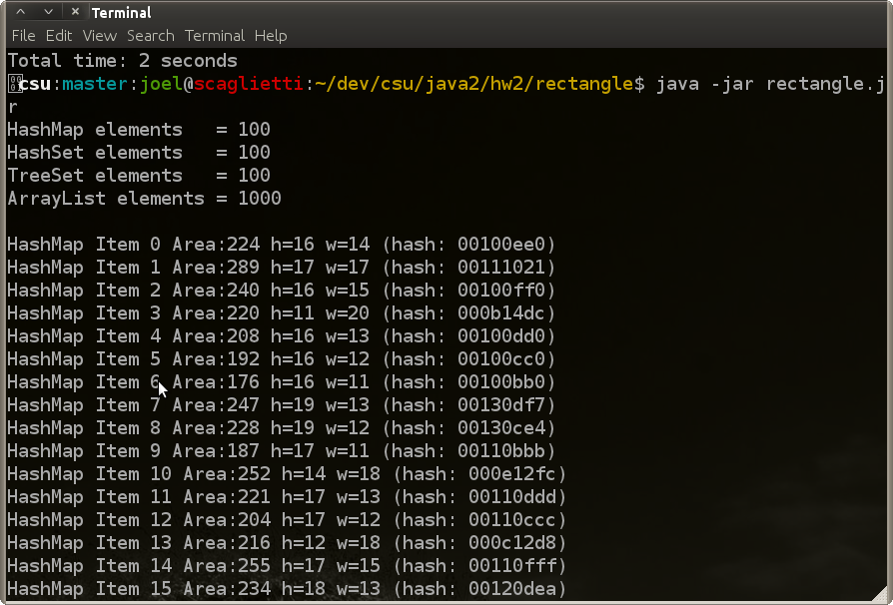Illustration 1: Random Values from 10 - 19
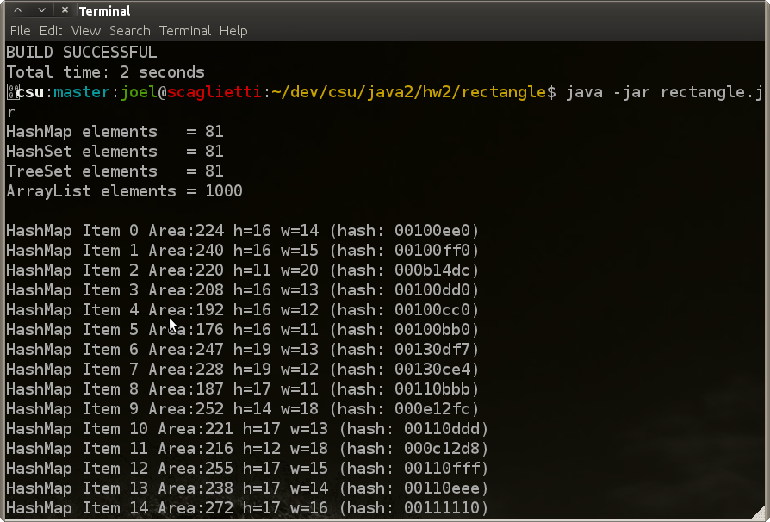Illustration 2: Random Values from 0 - 29

Final Run Output:

csu:master:joel@scaglietti:~/dev/csu/java2/hw2/rectangle$ java -jar rectangle.jr
HashMap elements = 81
HashSet elements = 81
TreeSet elements = 81
ArrayList elements = 1000

HashMap Item 0 Area:224 h=16 w=14 (hash: 00100ee0)
HashMap Item 1 Area:240 h=16 w=15 (hash: 00100ff0)
HashMap Item 2 Area:220 h=11 w=20 (hash: 000b14dc)
...
HashMap Item 78 Area:165 h=11 w=15 (hash: 000b0fa5)
HashMap Item 79 Area:195 h=13 w=15 (hash: 000d0fc3)
HashMap Item 80 Area:143 h=13 w=11 (hash: 000d0b8f)

HashSet Item 0 Area:224 h=16 w=14 (hash: 00100ee0)
HashSet Item 1 Area:240 h=16 w=15 (hash: 00100ff0)
HashSet Item 2 Area:220 h=11 w=20 (hash: 000b14dc)
...
HashSet Item 78 Area:165 h=11 w=15 (hash: 000b0fa5)
HashSet Item 79 Area:195 h=13 w=15 (hash: 000d0fc3)
HashSet Item 80 Area:143 h=13 w=11 (hash: 000d0b8f)

TreeSet Item 0 Area:121 h=11 w=11
TreeSet Item 1 Area:132 h=11 w=12
TreeSet Item 2 Area:132 h=12 w=11
...
TreeSet Item 78 Area:380 h=19 w=20
TreeSet Item 79 Area:380 h=20 w=19
TreeSet Item 80 Area:400 h=20 w=20

ArrayList Item 0 Area:320 h=20 w=16
ArrayList Item 1 Area:288 h=18 w=16
ArrayList Item 2 Area:400 h=20 w=20
...
ArrayList Item 997 Area:280 h=20 w=14
ArrayList Item 998 Area:220 h=11 w=20
ArrayList Item 999 Area:280 h=20 w=14

Key=00100ee0 Count=1
Key=000b14dc Count=148
Key=00100ff0 Count=1
Key=00100dd0 Count=1
Key=00100cc0 Count=2
Key=00100bb0 Count=16
Key=00130df7 Count=3
Key=00130ce4 Count=2
Key=00110bbb Count=16
Key=000e12fc Count=1
Key=00110ddd Count=1
Key=000c12d8 Count=3
Key=00110fff Count=2
Key=00110eee Count=3
Key=00141140 Count=8
Key=0013157c Count=10
Key=00101100 Count=2
Key=00131130 Count=3
Key=00111110 Count=1
Key=00121120 Count=1
Key=00140bdc Count=133
Key=000e10e0 Count=2
Key=000b10b0 Count=12
Key=00121032 Count=1
Key=000d10d0 Count=1
Key=00101010 Count=1
Key=00121568 Count=14
Key=00111332 Count=2
Key=00101320 Count=1
Key=00141054 Count=10
Key=00111554 Count=13
Key=0014127c Count=10
Key=00101540 Count=12
Key=00141368 Count=8
Key=000c13e4 Count=2
Key=000d13f7 Count=1
Key=000b11bb Count=8
Key=000d12ea Count=2
Key=000f11ff Count=1
Key=00120cd8 Count=1
Key=000d11dd Count=1
Key=00131043 Count=2
Key=00131269 Count=2
Key=000c14f0 Count=9
Key=00130bd1 Count=11
Key=00120bc6 Count=13
Key=000b0b79 Count=163
Key=00131356 Count=1
Key=000b13d1 Count=13
Key=00140cf0 Count=9
Key=000b12c6 Count=8
Key=00140e2c Count=12
Key=00140c04 Count=11
Key=000e1518 Count=13
Key=000d0c9c Count=1
Key=000c0ea8 Count=1
Key=000c0d9c Count=1
Key=000f0cb4 Count=1
Key=000d0eb6 Count=1
Key=000c0fb4 Count=1
Key=00140f18 Count=9
Key=000d1504 Count=9
Key=000f152c Count=9
Key=00141590 Count=106
Key=00120e0e Count=3
Key=00130f0a Count=1
Key=000b0e9a Count=13
Key=000e0ec4 Count=3
Key=000e0b9a Count=12
Key=000f0ed2 Count=2
Key=000e0fd2 Count=1
Key=000e120a Count=4
Key=000c0b84 Count=16
Key=000f121d Count=2
Key=000f130e Count=2
Key=000b0c84 Count=15
Key=000b0d8f Count=20
Key=000f0ba5 Count=13
Key=000b0fa5 Count=14
Key=000d0b8f Count=11
Key=000d0fc3 Count=1

